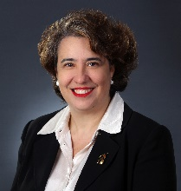  Angelina Angelov, CLM, MBA  Director  Russin Vecchi & Heredia Bonetti  Santo Domingo, DN  Dominican Republic  809-535-9511  aangelov@rvhb.com | 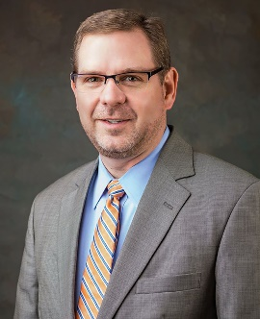  Travis C. Armstrong, CLM, CPA  Director  English Lucas Priest & Owsley, LLP  Bowling Green, KY  270-781-6500  tarmstrong@elpolaw.com
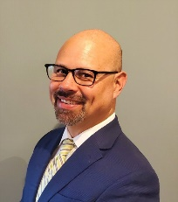  Daniel P. Atcheson  Incoming Director  Jenkins Taylor & Hunt, P.A.  Morrisville, North Carolina  919-313-4308  Datcheson@jthiplaw.com | 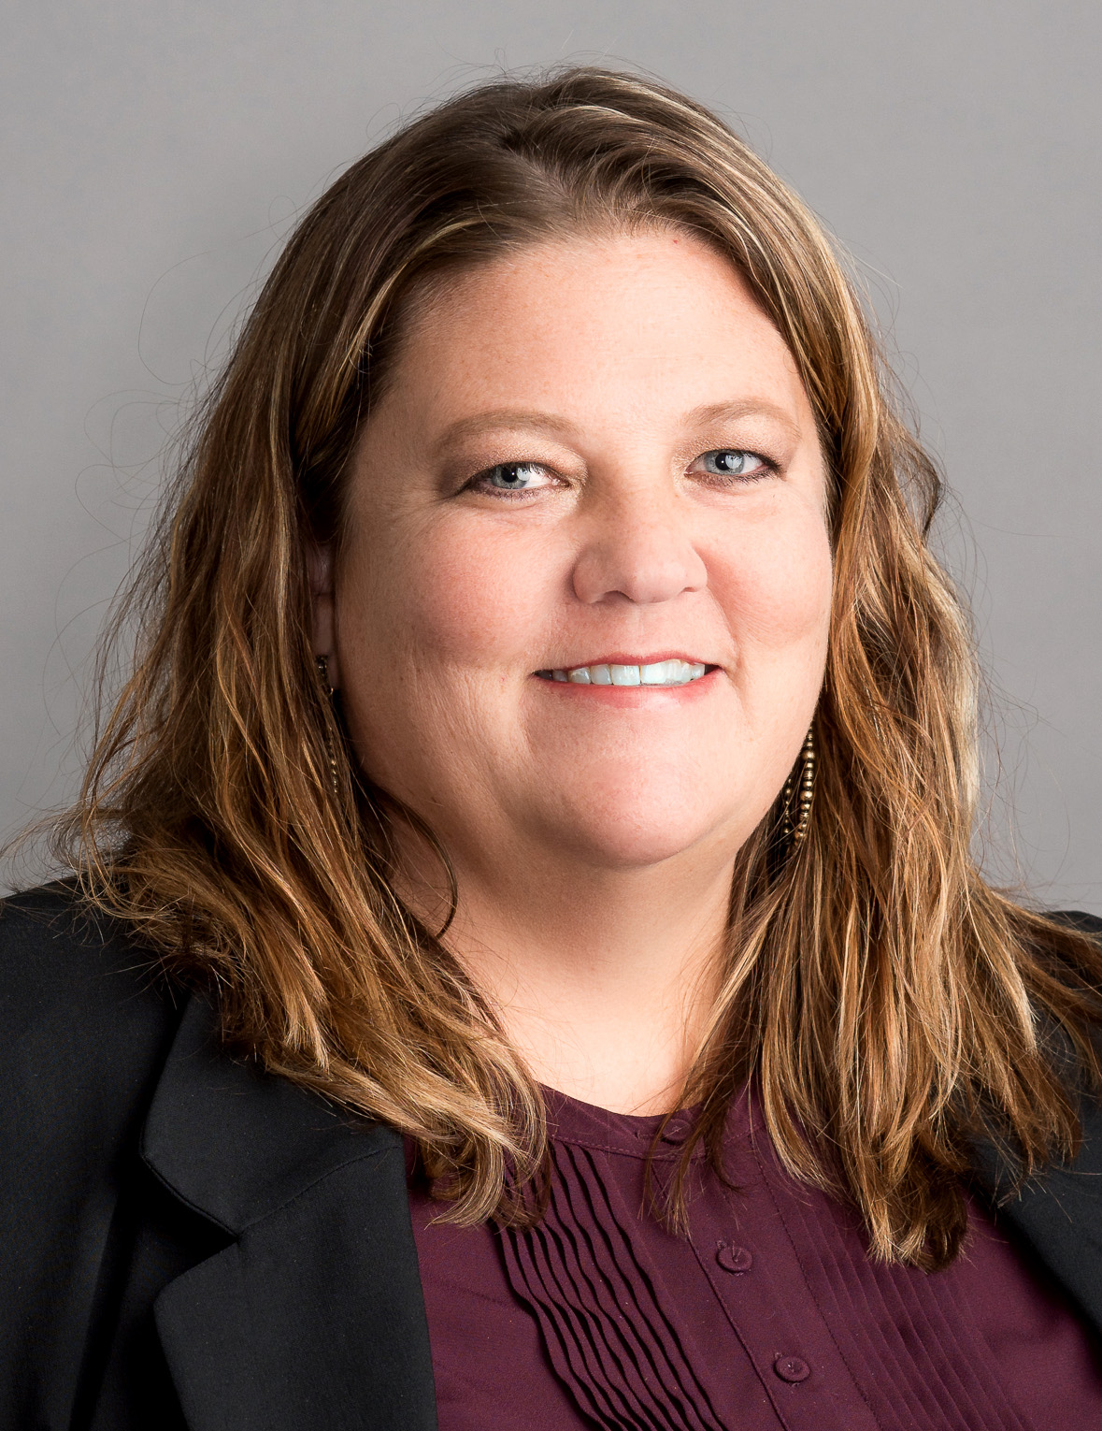  Kara M. Brostron, CLM  Product and Services Review Committee Chair  Lashly & Baer, PC  St. Louis, MO  314-436-8366  kmbrostron@lashlybaer.com
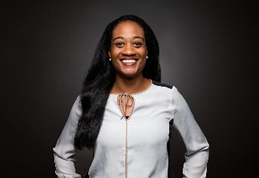  Ericka R. Brundage  Intellectual Property Conference for Legal Management Professionals Planning Committee Chair  Merchant & Gould, PC  Alexandria, VA  225-333-8379  Ebrundage@merchantgould.com | 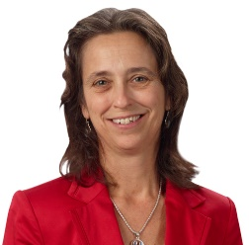  Linda M. Copson, CLM  Legal Management Fundamentals Planning Committee Chair  Downs Rachlin Martin, PLLC  St. Johnsbury, VT  802-473-4205  Lcopson@drm.com
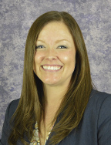  Sarah E. Cramer  Incoming Director  Baker Sterchi Cowden & Rice, LLC  Kansas City, MO  816-448-9370  scramer@bakersterchi.com | Katherine E. Dart  Chapter Resource Team Member  Kennedys Law LLP  Basking Ridge, NJ  908-848-1225  katherine_dart@outlook.com
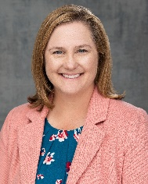  Sarah L. Evenson, JD, MBA  Immediate Past President  Barnes & Thornburg, LLP  Minneapolis, MN  612-367-8717  sarah.evenson@btlaw.com | Rhonda Fagen  Incoming Member Ambassador Committee Chair  McAngus Goudelock & Courie, LLC  Raleigh, NC  919-414-6107  Rhonda.fagen@mgclaw.com
Lisa R. Ford  Chapter Resource Team Member  Holland & Knight LLP  213-896-2560  Lisa.ford@hklaw.com | 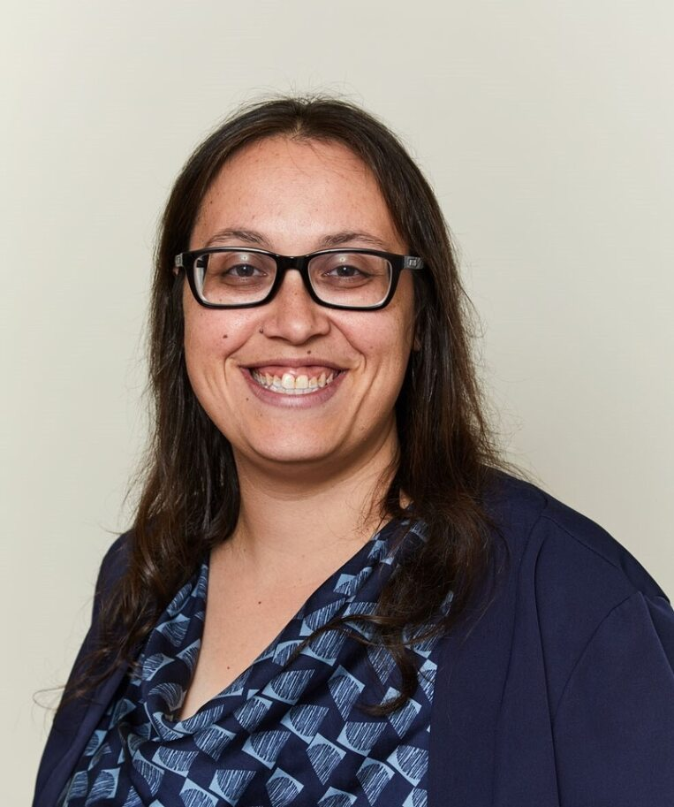  Elyssa A. Goldstein, CLM, PHR, SHRM-CP  Director  Rebenack Aronow & Mascolo, LLP  New Brunswick, NJ  732-247-3600  egoldstein@ram.law
Judy Hissong, CLM, PCC  Director  Nesso Strategies  San Diego, CA  619-546-7885  Judy@nessostrategies.com | Rose A. Jaworecki  Chapter Resource Team Member  Thompson Hine, LLP  New York, NY  212-908-3989  rose.jaworecki@thompsonhine.com
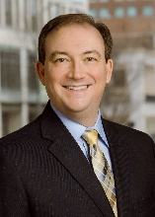 | 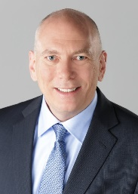
Michael E. Keatts  Chapter Resource Team Member  Bowman and Brooke LLP  Richmond, VA  804-819-1135  michael.keatts@bowmanandbrooke.com | Ken Koehn, CLM, CPA, CMA  Incoming Director  Gould & Ratner LLP  Chicago, IL  312-899-1620  Kkoehn@gouldratner.com
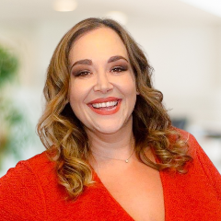  Amanda R. Koplos, CLM, CPA  President-Elect  Shuffield Lowman & Wilson, PA  Orlando, FL  407-581-9800  akoplos@shuffieldlowman.com | Shauna L. Manner, CLM, MBA, CPA, SHRM-SCP  Chapter Resource Team Member  Larkins Vacura Kayser, LLP  Portland, OR  503-222-4424  smanner@lvklaw.com
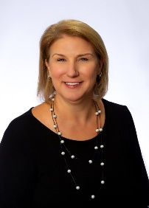  Kristie Lynn Manning, CLM  Foundation of ALA Trustee  Nathan Sommers Jacobs  Houston, TX  713-892-4891  Kmanning@nathansommers.com | Nicholas T. Manty  Chapter Resource Team Member  Maslon LLP  Minneapolis, MN  612-672-8260  nick.manty@maslon.com
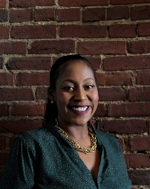  JaNae D. Martin  Incoming Diversity, Equity, Inclusion and Accessibility Committee Chair  Helmers + Associates  Louisville, KY  502-581-0077  Jmartin@helmerslaw.com | Jerry G. McPeake, MSLA  Director  Minor & Brown PC  Denver, CO  303-376-6004  jmcpeake@mb-law.law
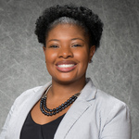  Terri D. Moore-Natal, SPHR  Director  Holzer Patel Drennan  Denver, CO  720-204-5732  tmoorenatal@hpdlaw.com | 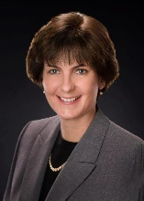  Clara E. Onderdonk, CLM  Director  Ernstrom & Dreste, LLP  Rochester, NY  585-473-3100  conderdonk@ed-llp.com
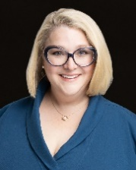  Holly K. Pulido  Director  Burch Porter Johnson, PLLC  Memphis, TN  901-524-5000 X5160  Hpulido@bpjlaw.com | Stephanie Rose Ransom, CLM  Incoming Certification Committee Chair  Marshall Dennehey, PC  New York NY  212-376-6452  Srransom@mdwcg.com
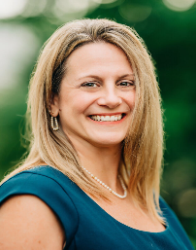  Andrea C. Stitt  Incoming Membership Experience Committee Chair  Stotler Hayes, LLC  Pawleys Island, SC  843-997-0425  Akirksey@stotlerhayes.com | 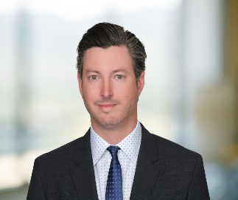  Matthew Paul Sullivan, JD  Incoming Professional Development Advisory Committee Chair  Sullivan Law & Associates  Newport Beach, CA  949-590-8100  Msullivan@sullivan-law.com
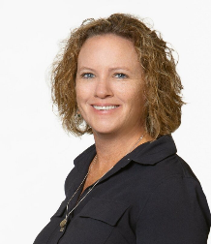  Melissa G. Tokar  Executive Leadership Summit Committee Chair  Irwin Fritchie Urquhart Moore & Daniels, LLC  New Orleans, LA  504-310-2110  Mtokar@irwinllc.com | 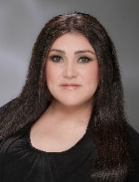  Carrie Valenzuela, MBA  Chapter Resource Team Member  Meagher & Geer, PLLP  Scottsdale, AZ  480-624-8582  cvalenzuela@meagher.com
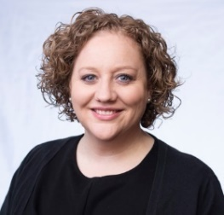  Jessica VanTroost  Director  McGlinchey Stafford, PLLC  Jacksonville, FL  904-224-4473  Jvantroost@mcglinchey.com | 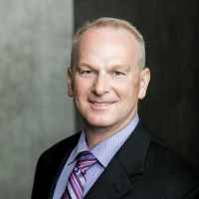  Geoffrey M. Williams, CLM, MBA, M.Div.  President  Stone Pigman Walther Wittmann L.L.C.  New Orleans, LA  504-593-0940  Gwilliams@stonepigman.com
Sharon M. Williams
Chapter Resource Team Member
Lewis Brisbois
Phoenix, AZ
602-792-1486
Sharon.Williams@lewisbrisbois.com

View ALA headquarters staff roster and biographies here.

